Regulations:
A14

H.T No

Sreenidhi Institute of Science and Technology
(An Autonomous Institution)
Code No: 4H213 Date: 28-Dec-2018 (FN)

B.Tech I-Year II-Semester End External Examination, Dec-2018/Jan-2019 (Supplementary)
ENGINEERING MATHEMATICS – II (Common to All except BT)

Time: 3 Hours Max.Marks:70

Note: a) No additional answer sheets will be provided.
b) All sub-parts of a question must be answered at one place only, otherwise it will not be valued.
c) Missing data can be assumed suitably.

Part - A Max.Marks:20

Answer all QUESTIONS.

1. | If the rank of the matrix 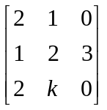is 2, compute the value of | [2M]
2. | If the sum of the Eigen values of 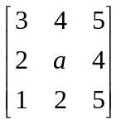 is 10, then compute 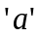 | [2M]
3. | Form a partial differential equation by eliminating the arbitrary function 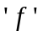 from  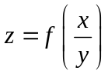 | [2M]
4. | Determine 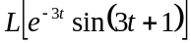 | [2M]
5. | State Damping rule of Z- transform | [2M]
6. | Find a₀ of Fourier series expansion of the Function f(x) = 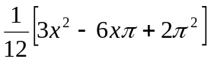in the interval (0,2) | [2M]
7. | If 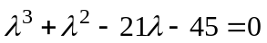 is the characteristic equation of a matrix , find det A. | [2M]
8. | Find the complete integral of Z = px + qy + pq. Where p and q are first order partial  derivatives of z , w.r.to x and y respectively. | [2M]
9. | Find the Z – Transform of 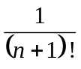 | [2M]
10. | Write the Dirichlet’s conditions | [2M]
Part – B Max.Marks:50
ANSWER ANY FIVE QUESTIONS. EACH QUESTION CARRIES 10 MARKS.

11. | a) | Solve by Gauss-Seidel method | [5M]
 | b) | Reduce the matrix 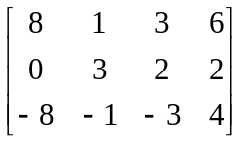into normal form. Hence find its rank | [5M]
12. | a) | If 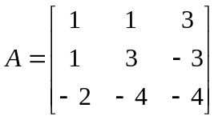, find 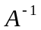 using Cayley-Hamilton theorem | [5M]
 | b) | Find Eigen values and Eigen vectors of the matrix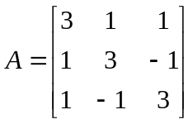 | [5M]
13. | a) | Find the general solution of the partial differential equation 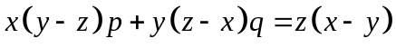. | [5M]
 | b) | Reduce the differential equation 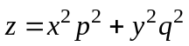 to the form 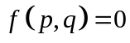 and hence solve it. | [5M]
14. | a) | Find the Laplace transform of 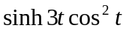 | [5M]
 | b) | Find the inverse Laplace transform of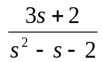 | [5M]
15. | a) | Find the 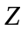- transform of 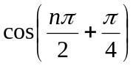 | [5M]
 | b) | If 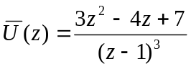 is the Z – transform of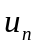, then find 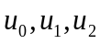 | [5M]
16. | a) | Determine the Fourier series for 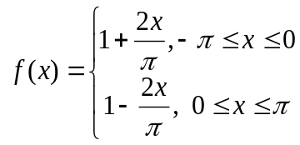 in 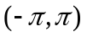 | [5M]
 | b) | Obtain the half range cosine series 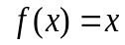 in 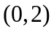 | [5M]
17. | a) | Solve the system of equations x + 3y + 2z = 0 , 2x – y + 3 z =0  x-5y + 4z = 0, x + 17y + 4z=0 | [5M]
 | b) | Solve the equations by Gauss-Jordan method | [5M]
18. | a) | Find 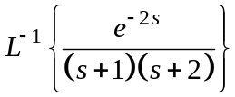 . | [5M]
 | b) | Using Z – transform, solve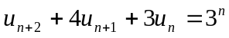 with 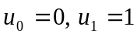 | [5M]

-- 00 -- 00 –

